|  |  |
| --- | --- |
|  |  |
| USER MANUALLibrary Website |  |
|  |  |
|  | Fall 2022CEN 4010 – RVD |
|  | Team 12 |

Table of Contents

1. General Information 2
2. User Accounts 2

2.1 Account Creation 2

2.1.1 Account Creation via the Admin Page 2

2.1.2Account Creation via the Library Website 4

2.2 Editing an Account 5

2.3 Permissions 6

2.3.1 Permission Types 6

2.3.2 Creating Group Permissions 6

1. Catalog 8

3.1 Categories 8

3.1.1 Books 8

3.1.2 Authors 9

3.1.3 Other Categories 10

3.2 Search Bar 11

3.3 Other Catalog Features 11

3.3.1 Book of the Day Collection 11

3.3.2 Similar Book Recommendations 11

3.4 Editing Catalog Content 12

1. Library Information 12

4.1 About 12

4.2 Calendar 13

4.3 Contact 13

4.3.1 Contact Staff View 14

1. Dark Mode 15
2. Glossary 16

## 1. General Information

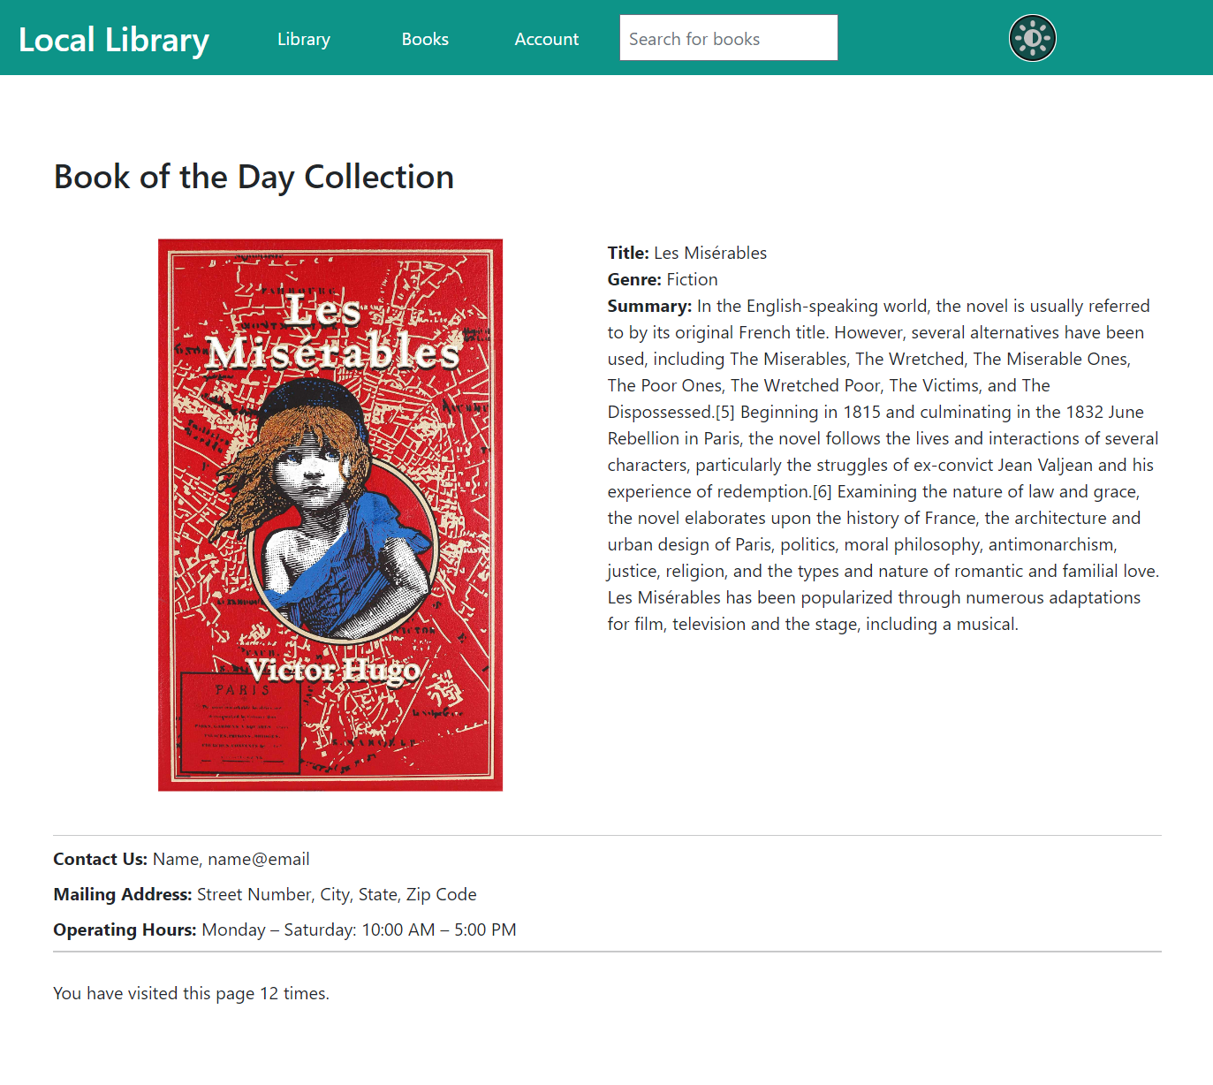The Local Library Website is designed and developed to be used by Local branch of Library. (Figure 1-1) It has the full functionality of a library website, including viewing the library’s catalog of books, borrowing books from the library, viewing library events and information, and contacting the library staff. The website is developed to be used by a wide variety of clients. It is designed with simplicity and accessibility in mind.

Figure 1‑1   
Library Home Page

## 2. User Accounts

The website allows the creation and use of several types of user accounts: administrative, staff, and library user. The administrative accounts are for those who do maintenance on the website (such as information technology (IT) staff). The staff accounts are for those who upkeep the library (such as librarians). Lastly, the library user accounts are for the patrons of the library. Each type of account has different features that they are allowed to do.

#### 2.1 Account Creation

Regardless of the type of account, account creation can be done in one of two ways: via the admin page or via the library website.

2.1.1 Account Creation via the Admin Page

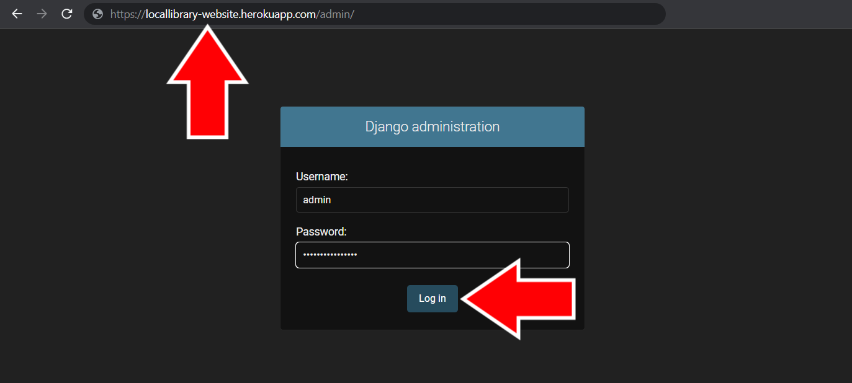**Administrative** or **Staff** accounts can create new user accounts from the admin page of the website. Below are the steps to create an account on the admin page:  
  
1) In your website browser, go to the admin page at [librarywebsite].com/admin and login with an administrative or staff account. (Figure 2-1)

Figure 2-1   
Admin Page Login

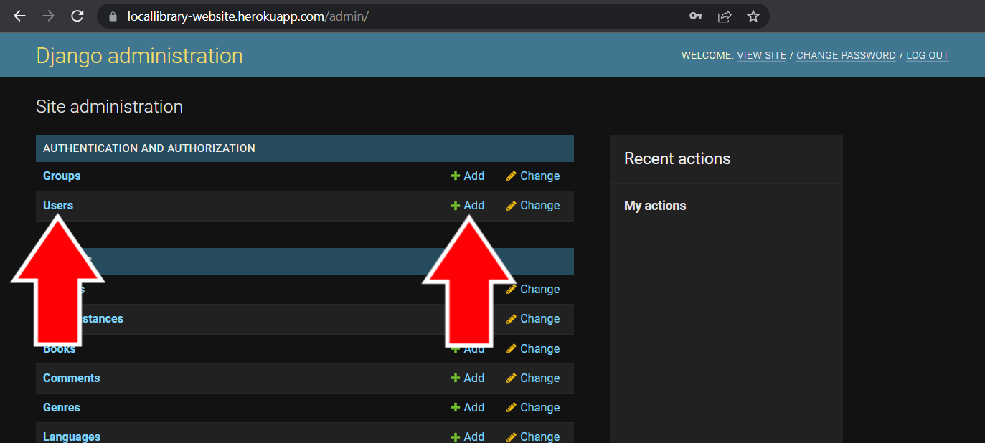2) Once logged in, you’ll be taken to the **Site Administration** page. Underneath the **Authentication and Authorization** category, either click on **Users** on the left or click on the **+ Add** button on the right side next to **Users**. (Figure 2-2) If you pressed the **+Add** button, skip to step 4.

Figure 2-2   
Site Administration Page

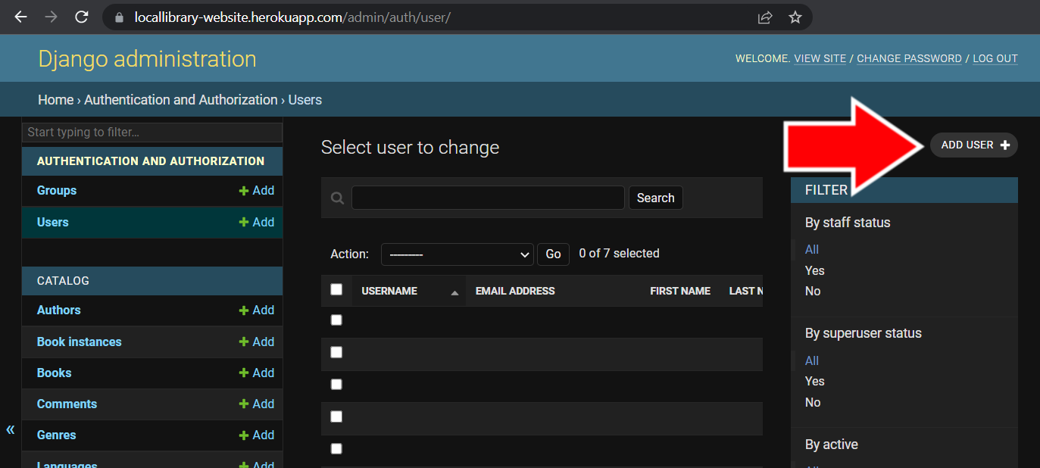3) Once on the **User** page, click the **Add User +** button in the top right corner to start creating a user account. (Figure 2-3)

Figure 2-3   
Admin Users Page

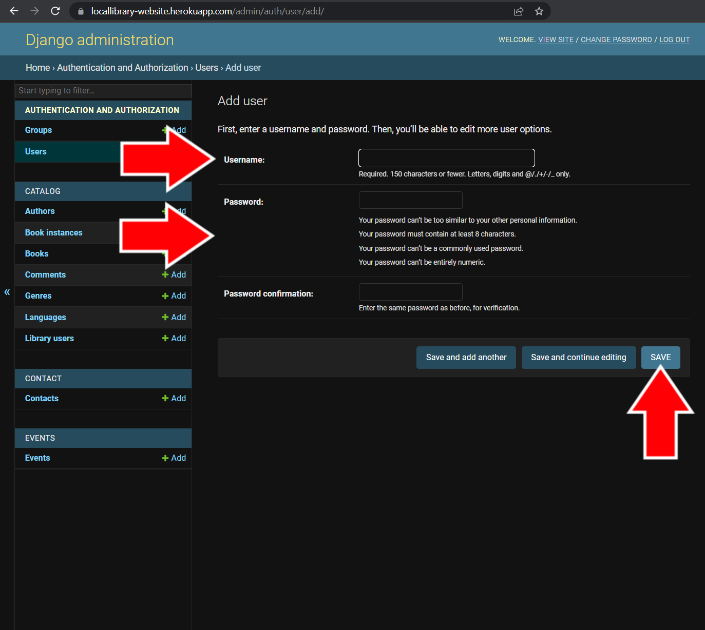4) On the user creation page, create the username and add a secure password. (Figure 2-4) Be sure to create a secure password that doesn’t include the username, contains at least 8 characters, isn’t commonly used, and contains both numbers and letters.

When finished, click the **Save** button at the bottom right. (Figure 2-4) After creating an account, you’ll be able to add more information such as name and e-mail.

Figure 2-4   
User Account Creation Page

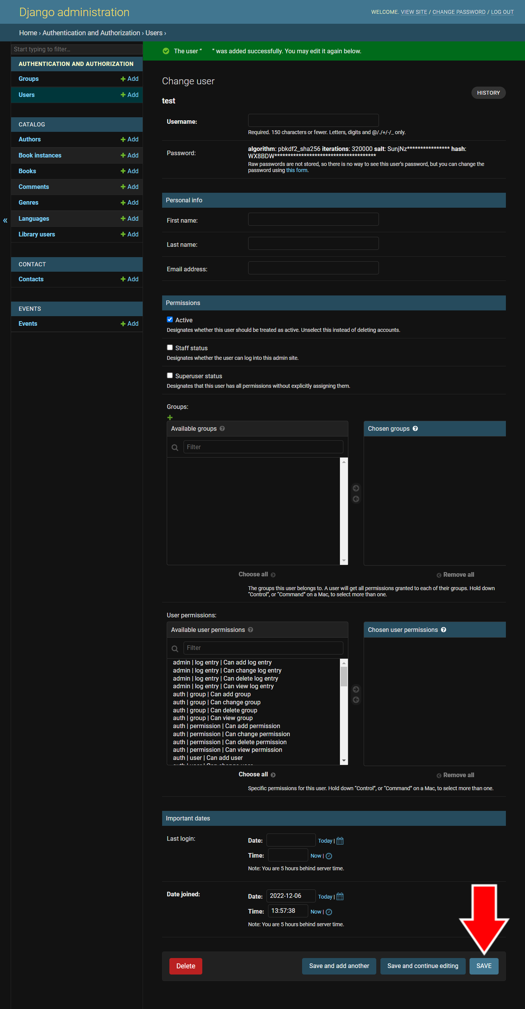5) Upon successful account creation, you’ll be taken to the **Change user** page, (Figure 2-5) where you can fill in the details of the account.

On this page, you can change the account’s username and password.

Under **Personal Info**, add the user’s first name, last name, and e-mail address.

Under **Permissions**, you can set the permissions for the account. The **Active** status indicates whether or not the account can be used or if the user is “active”. The **Staff status** option indicates whether or not the account is for a staff member’s use. This selection gives the account all of the permissions of a staff account (renewing books, editing books, etc.; see section 3 for more information). The **Superuser status** option indicates whether or not the account is for use by a “superuser,” or someone who is in charge of maintaining the website (such as IT staff).

**Groups** are sets of permissions you can assign to specific accounts. **User permissions** are how the account can interact with features of the website and admin page. It is recommended that you assign accounts to **Groups** instead of setting individual user permissions.

Once finished setting up the user account and filling in the information, press the **Save** button in the bottom right corner.

Figure 2-5   
Change User Page

2.1.2 Account Creation via the Library Website

Anyone can initiate the creation of an account via the Library Website. Below are the steps to create an account on the Library Website:

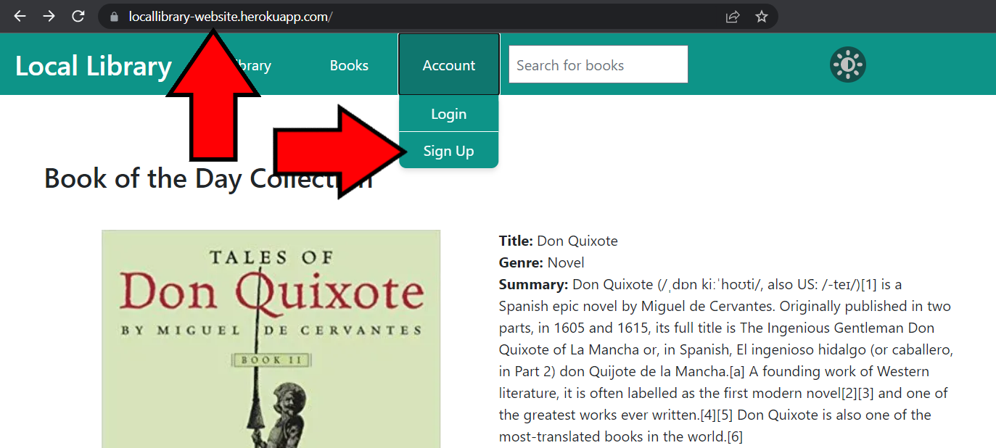1) In your web browser, go to the library website at [librarywebsite].com. Once on the Library Website home page, click on the **Account** drop-down menu and select **Sign Up**. (Figure 2-6) This will take you to the account sign up page.

Figure 2-6   
Library Home Page Showing Sign Up Button

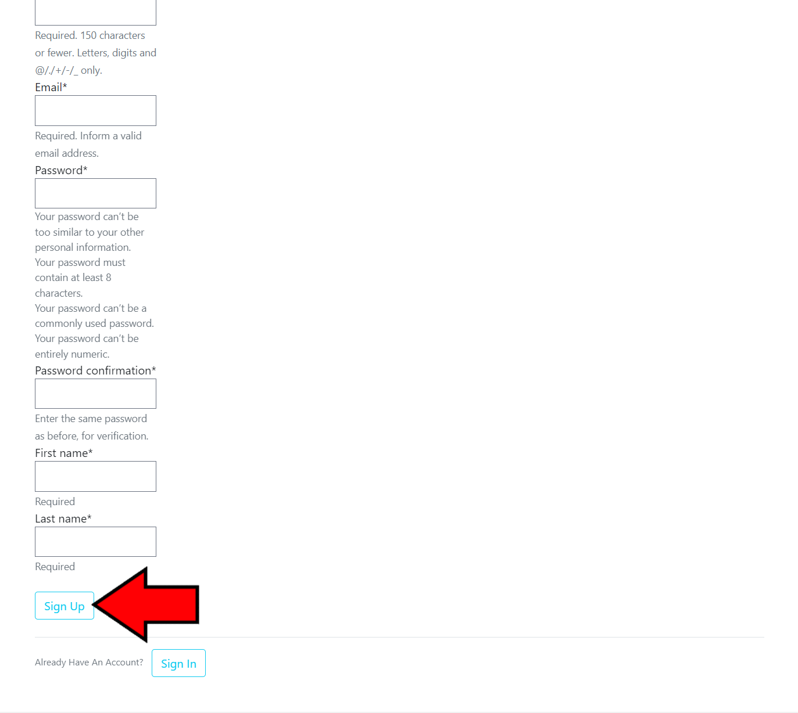2) You’ll be taken to the **Join Today** account sign up page. Here, you’ll be able to enter the account information such as username, e-mail, password, first name, and last name.

When creating a password, be sure to not include the username in the password, make sure it’s at least 8 characters long, don’t use a common password, and be sure to use letters and numbers. Once all of the information has been entered, press the **Sign Up** button at the bottom of the page. (Figure 2-7) A user account will be created and become inactive.

Figure 2-7  
 Join Today Page

Once an account has been created, a librarian needs to set the account to active in order for the user to login to the account (see section 2.1.1, number 5 for more information).

#### 2.2 Editing an Account

Once a user account has been created, the information and permissions on the account can be changed by an administrative or staff account on the admin page. Below are the steps the change a user account’s information:

1) In your website browser, go to the admin page at [librarywebsite].com/admin and login with an administrative or staff account. (Figure 2-8)

Figure 2-8   
Admin Page Login

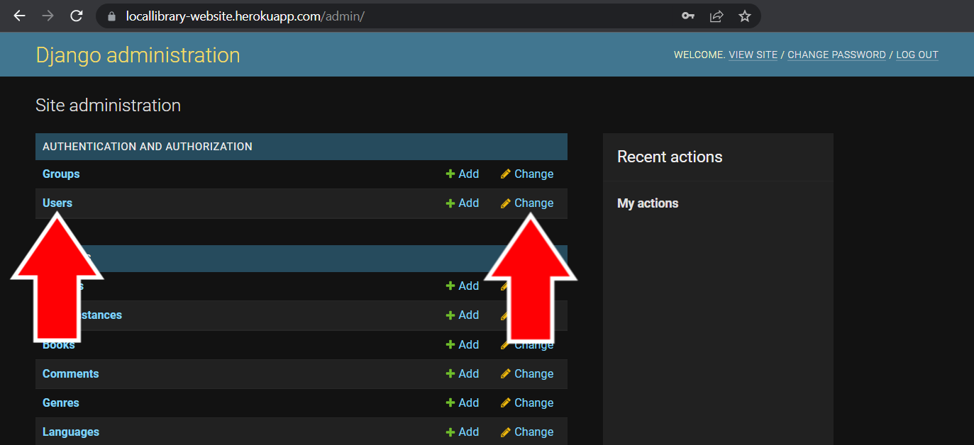2) Once logged in, you’ll be taken to the **Site Administration** page. Underneath the **Authentication and Authorization** category, either click on **Users** on the left or click on the **Change** button on the right side next to **Users**. (Figure 2-9)

Figure 2-9   
Site Administration Page

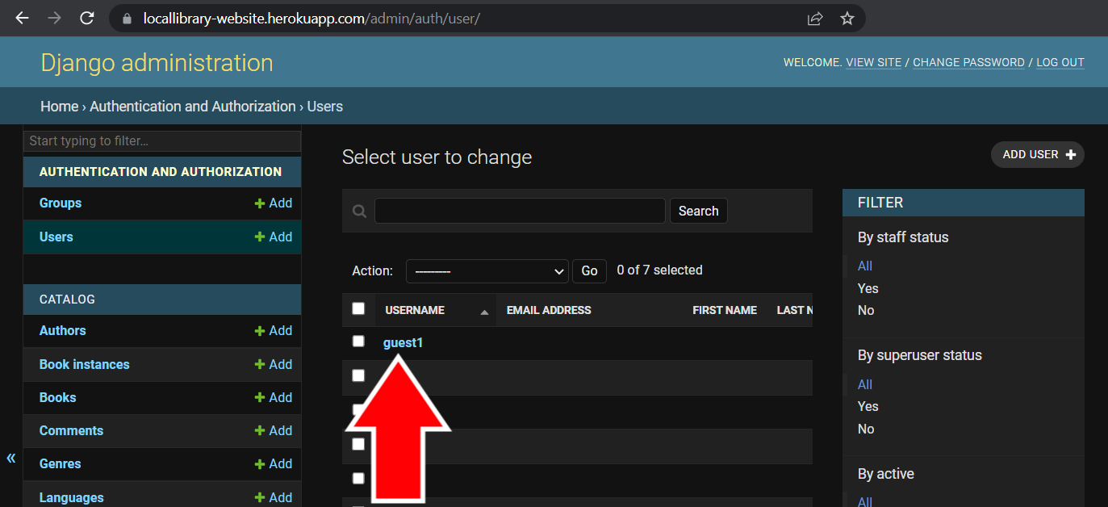3) Once on the **Users** page, select the user whose information you want to change. (Figure 2-10) You’ll be taken to the **Change user** page (see section 2.1.1, number 5 for more information). Here, you will be able to change the user’s username, password, name, e-mail, permissions group, and other information.

Figure 2-10   
Admin Users Page

#### 2.3 Permissions

The permissions on user accounts are the allowed features that account can interact with. It is important to make sure each account has the correct permissions.

2.3.1 Permission Types

Permissions are divided into groups based on which feature of the website they interact with. The following is a list of features currently available for the Local Library Website:

* **Admin, Auth,** **Content Types, Sessions** – These permissions are for administrative purposes and should only be given to high level staff or account users (such as IT staff or those who are responsible for maintaining the website).
* **Catalog** – These permissions are for changing the catalog and library user permissions.
* **Library User** – The library user subcategory is given to accounts who are allowed to borrow books from the library.
* **Other Subcategories** – All of the other catalog subcategories are for changing book information (books, copies, authors, genres, languages, and comments).
* **Contact** – These permissions are for interacting with the messages received from the **Contact Page** form.
* **Events** – These permissions are for changing event details on the **Calendar Page**.

2.3.2 Creating Group Permissions

Group permissions make it easy to keep track of which account has which permissions by grouping the permissions based on what kind of access certain types of user accounts get. Below are the steps to creating a group:

1) In your website browser, go to the admin page at [librarywebsite].com/admin and login with an administrative or staff account. (Figure 2-11)

Figure 2-11   
Admin Page Login

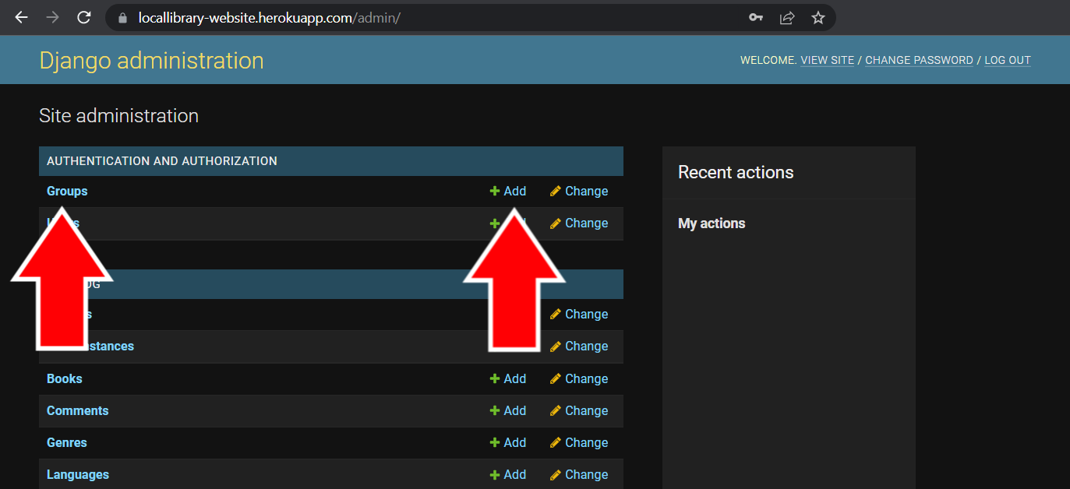2) Once logged in, you’ll be taken to the **Site Administration** page. Underneath the **Authentication and Authorization** category, either click on **Group** on the left or click on the **+ Add** button on the right side next to **Groups**. (Figure 2-12) If you pressed the **+ Add** button, skip to step 4.

Figure 2-12   
Site Administration Page

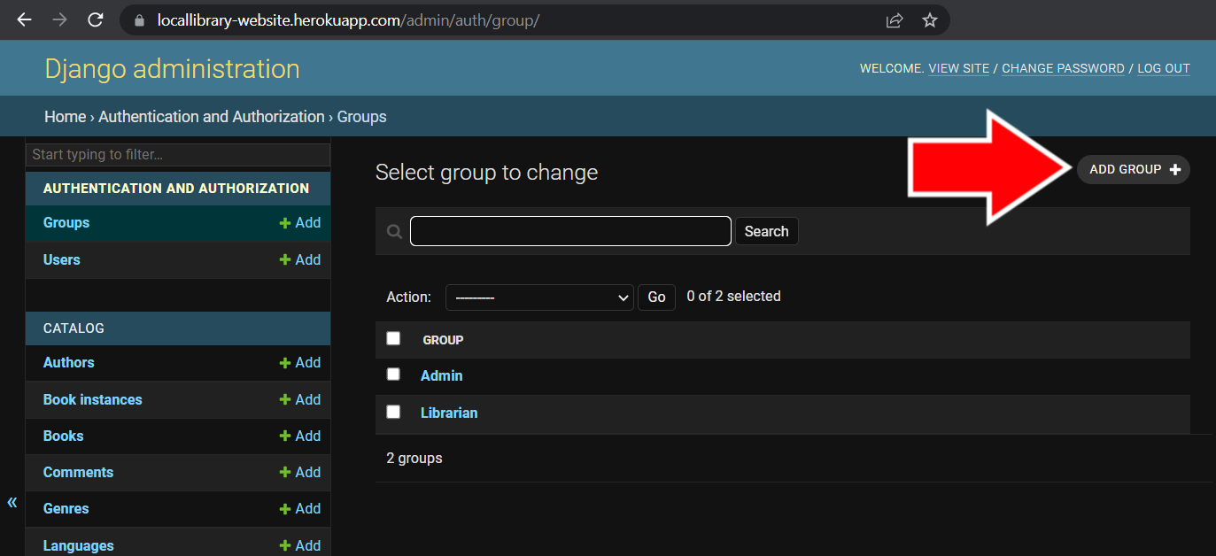3) Once on the **Groups** page, click the **Add Group +** button in the top right corner to start creating a permissions group. (Figure 2-13)

Figure 2-13   
Admin Groups Page

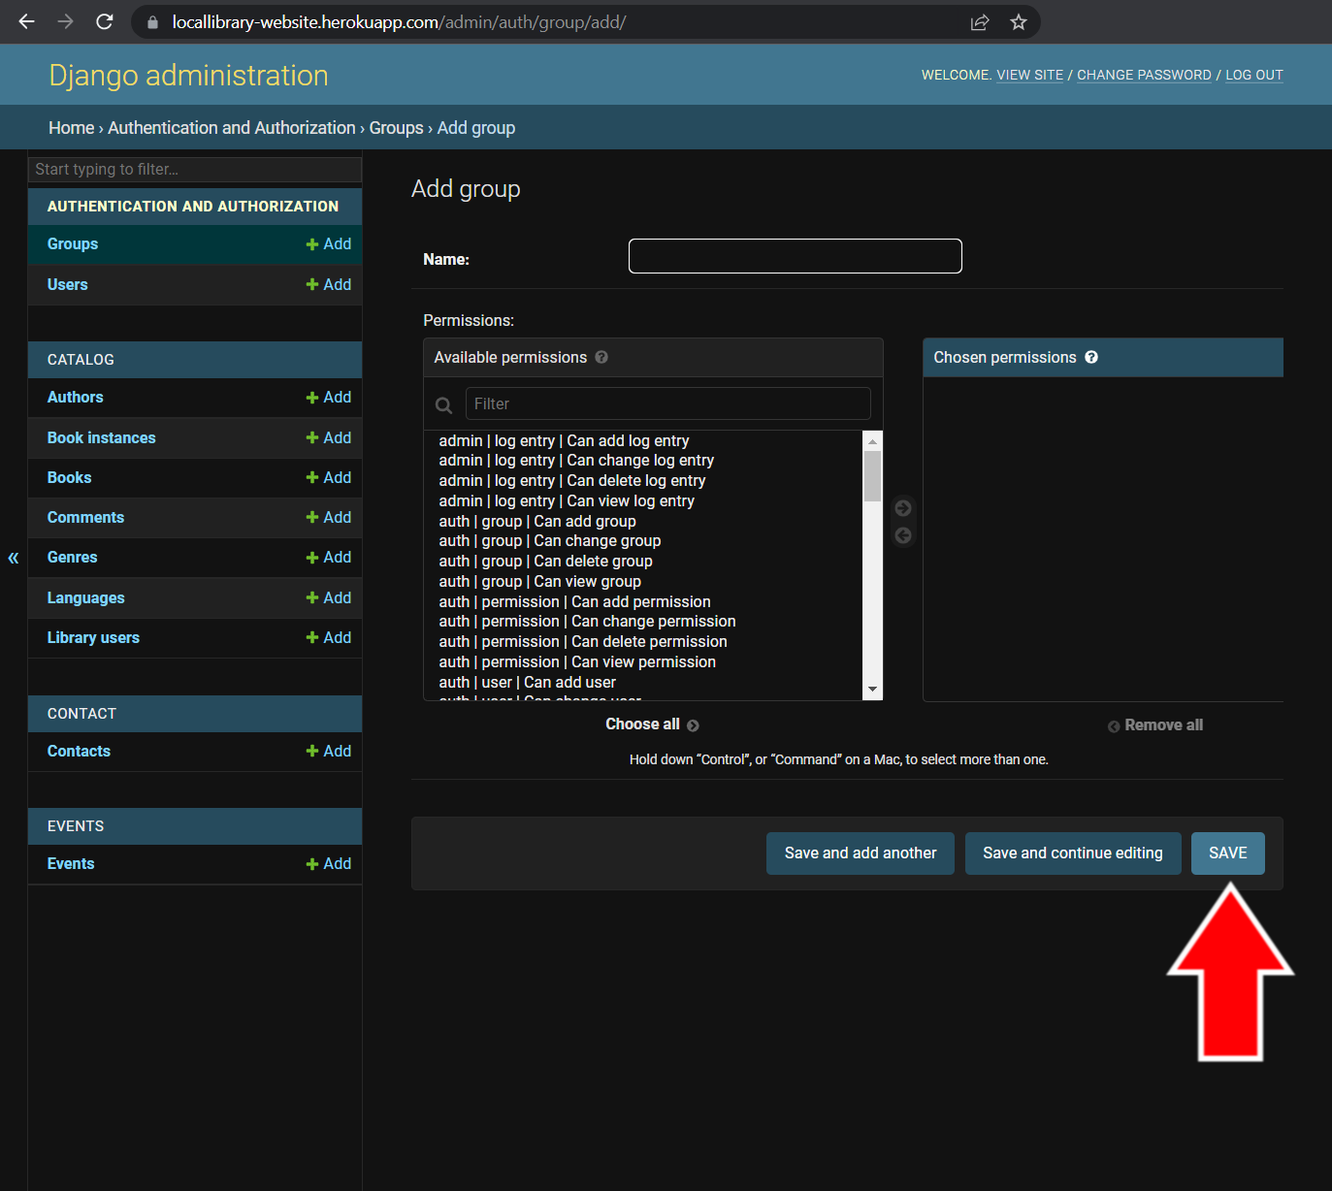4) On the **Add group** page, you can start adding permissions to your group. Give your group a meaningful name so you know which accounts it should apply to (ex: Librarian can edit catalog).

To add permissions to the group, select the permissions on the left side under **Available permissions** and click the arrow that points to the right between **Available permissions** and **Chosen permissions**. You can highlight multiple permissions and add them. To take away permissions, select the permissions you want to remove underneath **Chosen permissions** and click the left arrow between **Available permissions** and **Chosen permissions**.

Once finished changing permissions, click the save button at the bottom of the page. (Figure 2-14)

Figure 2-14 Add Group Admin Page

## 3. Catalog

The catalog is the section of the library website that holds all of the information for the books and calendar. It has several interactive features, discussed in the following sections.

#### 3.1 Categories

The books in the catalog are separated into several categories. Library users can view books according to each category.

3.1.1 Books

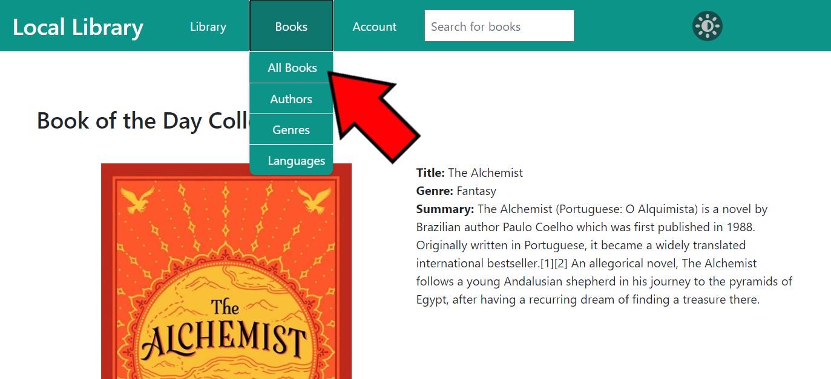The default category for viewing all of the books in the catalog is sorted by title name. To view all of the books in the catalog, click the **Books** button on the navigation bar to view the catalog drop-down menu and click on **All Books**. (Figure 3-1)

Figure 3-1   
Library Home Page Show All Books Button

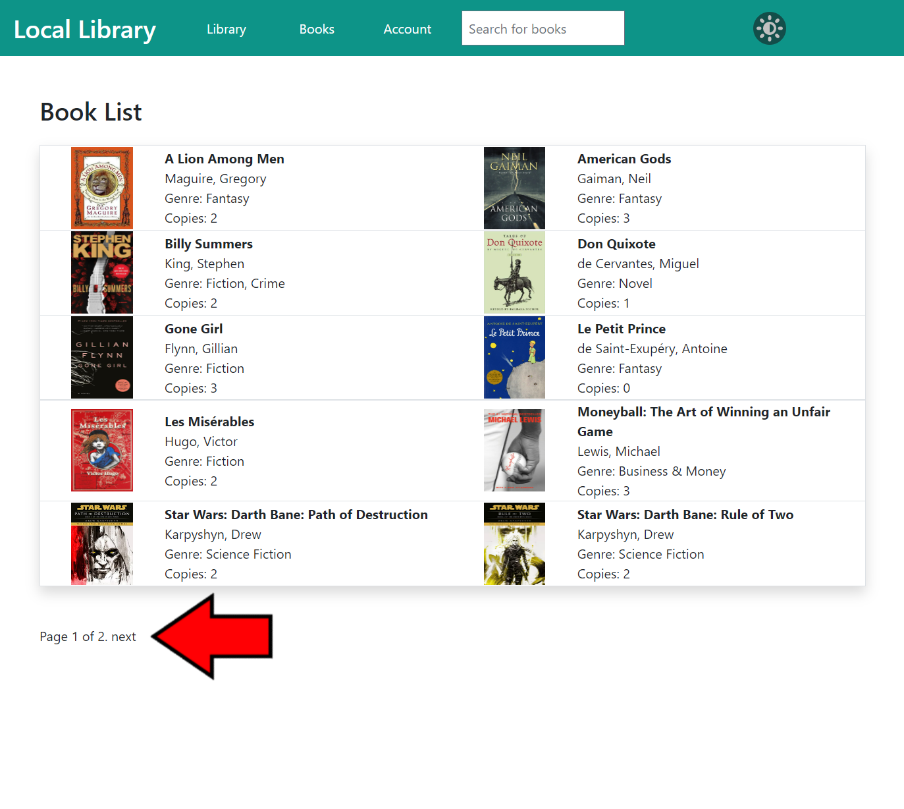This will bring you to the **Book List** page, where you can browse all of the books in the catalog. Next to each book you can view the title, author, genre, and how many copies are in the library. To view more information about the book or author, simply click on the name and you will be brought to that book or author’s detail page.

The book list is separated into groups of 10 on each page. Press the **Next** or **Previous** buttons at the bottom of this page to browse through the pages of books. (Figure 3-2)

Figure 3-2   
Book List Page

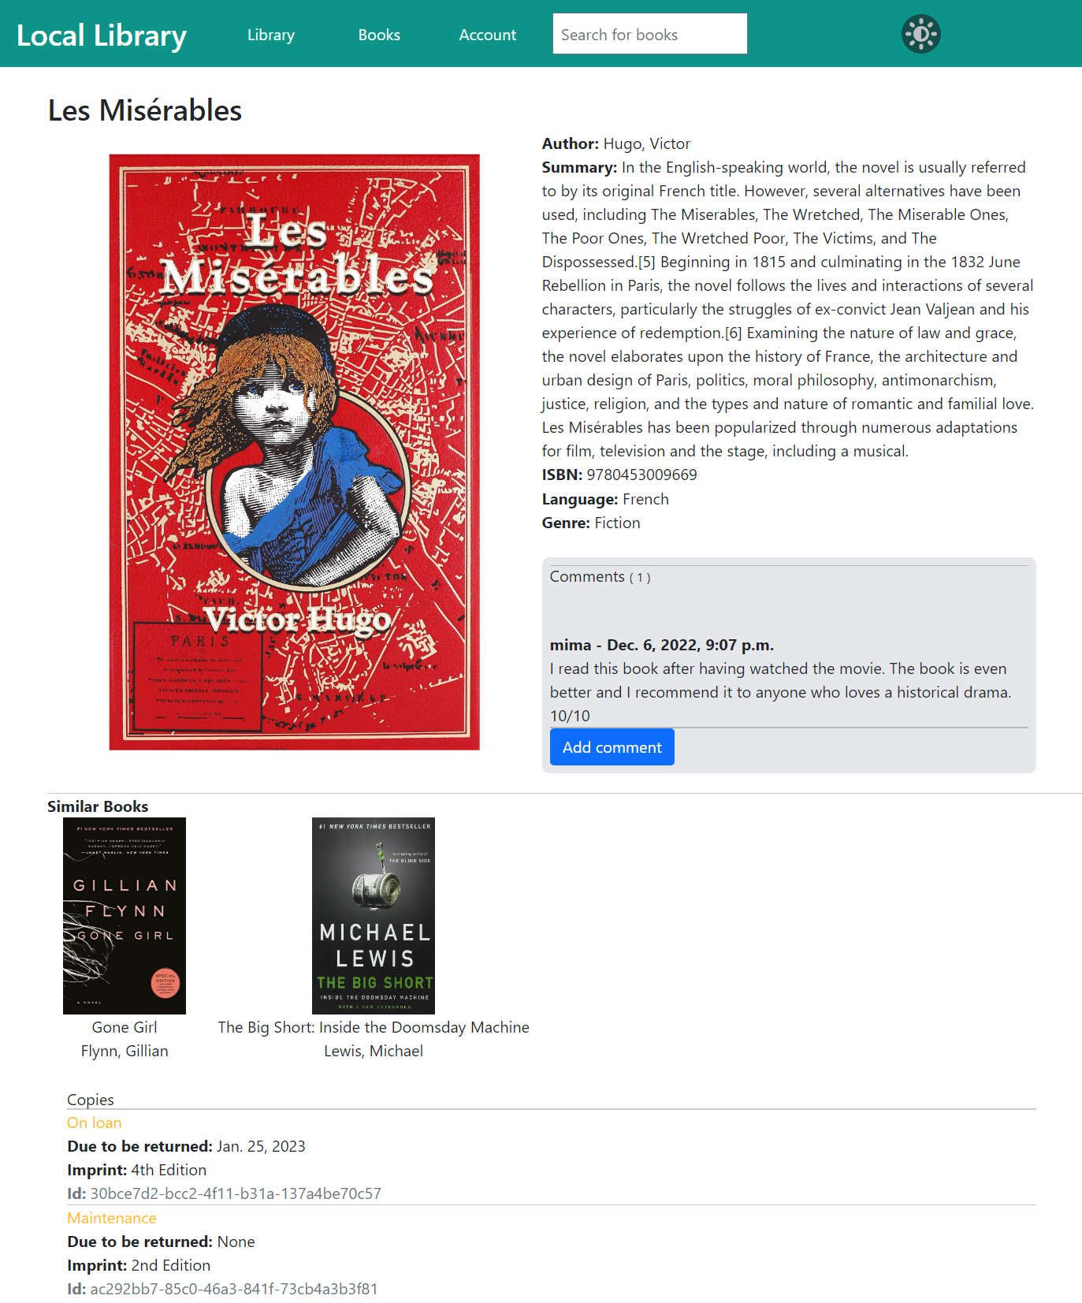Clicking on a book title brings you to the book’s detail page, which gives information on the book including title, author, summary, ISBN, language, genre, similar books (see section 3.3.2 for more information), copies, and comments that library users have left about the book. (Figure 3-3)

Figure 3-3   
Book Detail Page

3.1.2 Authors

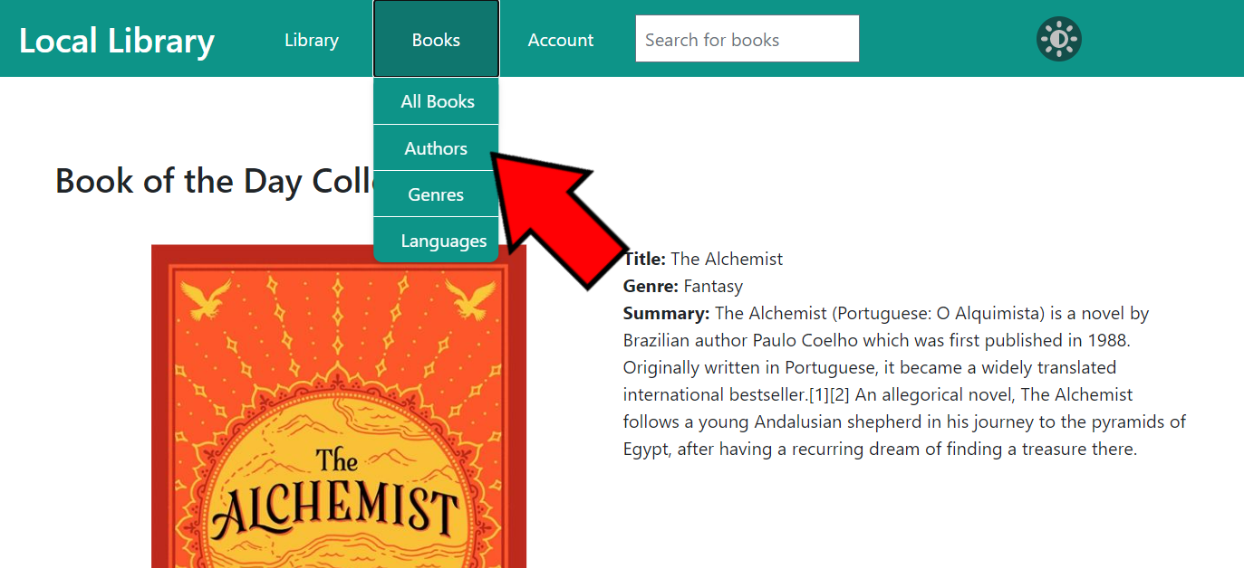Users can view all of the authors of the books in the library catalog by clicking the **Books** button on the navigation bar to view the catalog drop-down menu and clicking on **Authors**. (Figure 3-4)

Figure 3-4   
Library Home Page Showing Authors Button

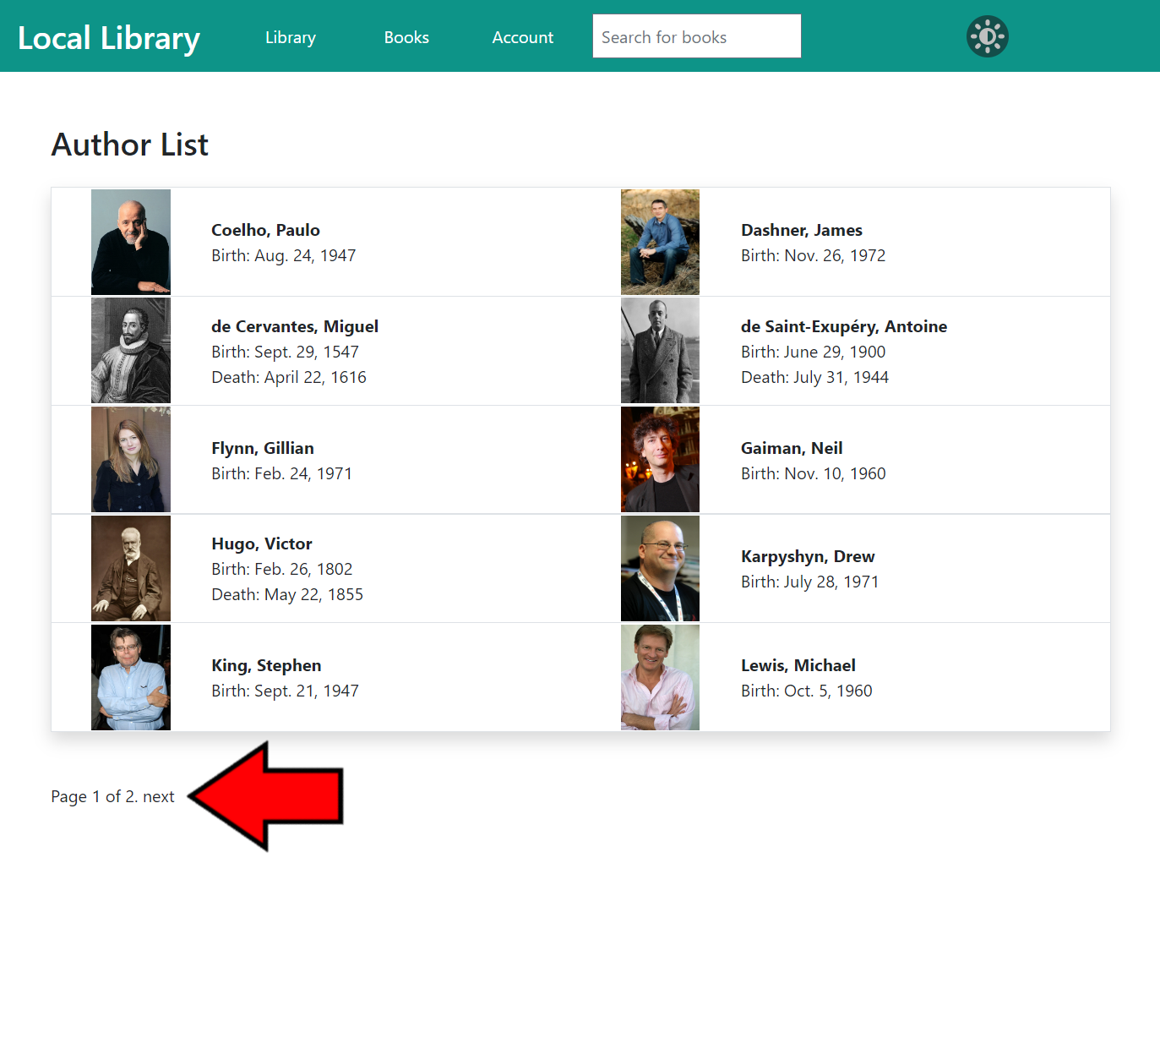This will bring you to the **Author List** page, where you can browse all of the authors of the books in the catalog. Next to each author you can view their name, date of birth, and date of death (if applicable). To view more information on an author, you can click on their name and be taken to their author detail page.

The author list is separated into groups of 10 on each page. Press the **Next** or **Previous** buttons at the bottom of this page to browse through the pages of authors. (Figure 3-5)

Figure 3-5  
Author List Page

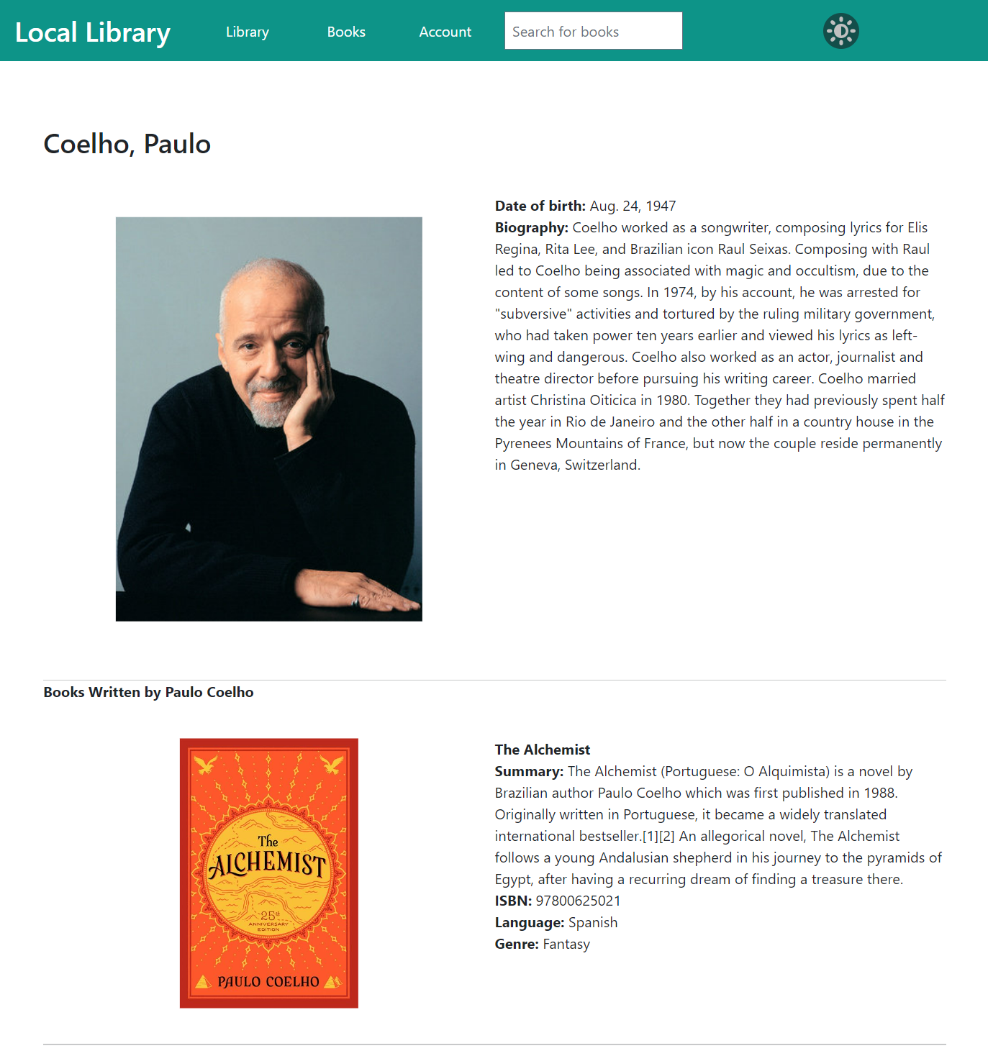Clicking on an author’s name brings you to the author’s detail page, (Figure 3-6) which gives information on that author including name, date of birth, date of death (if applicable), a small biography, and any books written by that author that are in the library’s catalog.

Figure 3-6  
Author Detail Page

3.1.3 Other Categories

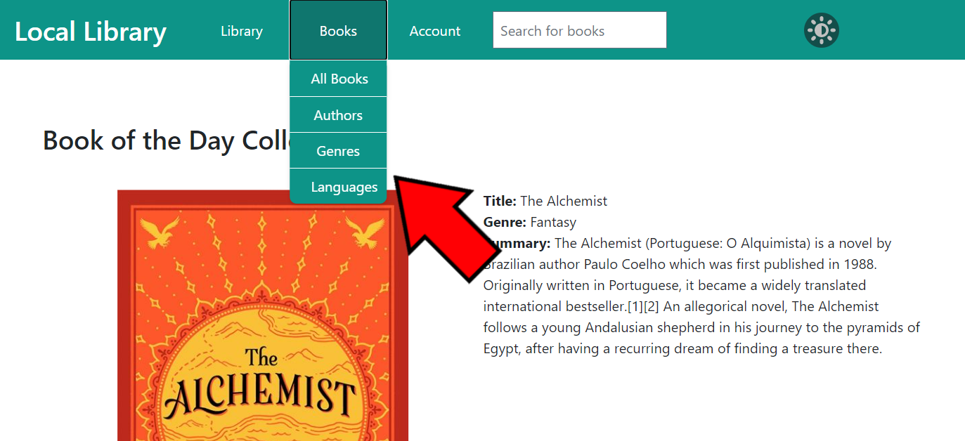Users can view all of the other categories of the books in the library catalog by clicking the **Books** button on the navigation bar to view the catalog drop-down menu and clicking on the appropriate category (either **Genre** or **Language**). (Figure 3-7)

Figure 3-7   
Library Home Page Showing the Other Category Buttons

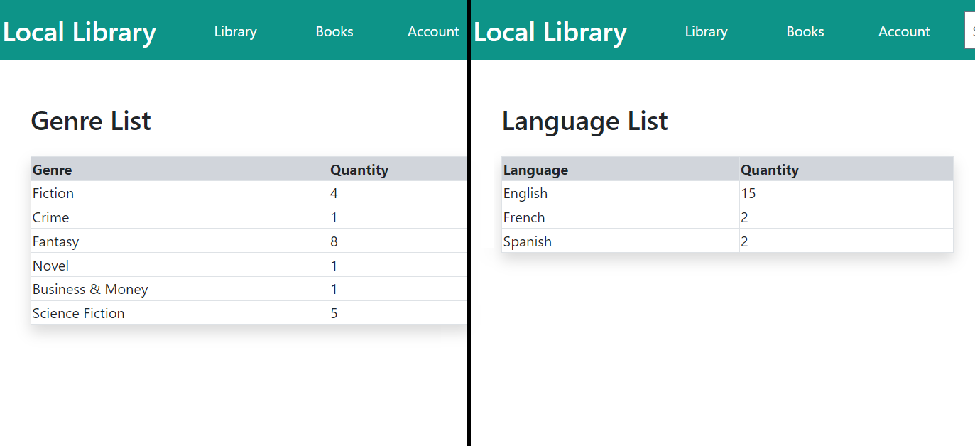This will bring you to the category list page where you can see a list of subcategories and the quantity of books in each subcategory. (Figure 3-8) If you click on **Genre**, you will see a list of all of the genres of books in the library catalog. If you click on **Language**, you will see a list of all of the languages of books in the library catalog.

Figure 3-8 Category List Pages

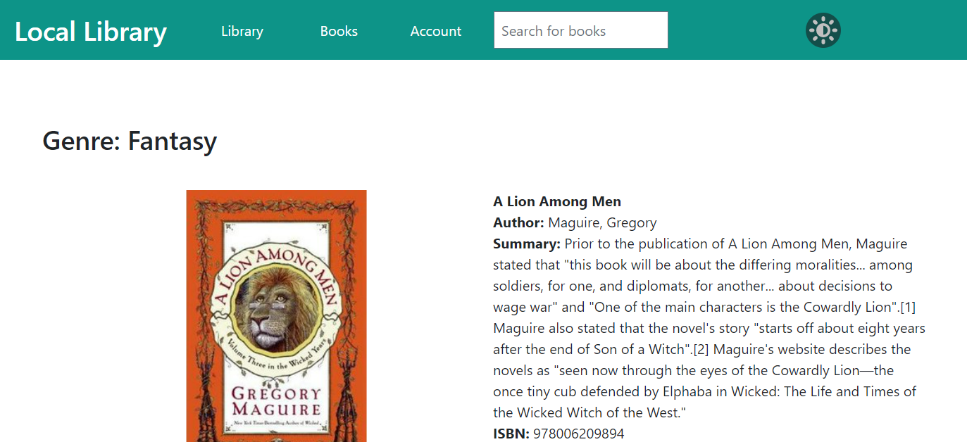   
Clicking on a genre or language will bring you to a list page of all of the books in that subcategory. (Figure 3-9) The list gives details of each book, including title, author, summary, ISBN, and any other category. To view more information about the book or author, you can click on its name and you will be brought to the detail page.

Figure 3-9 Subcategory List Page

#### 3.2 Search Bar

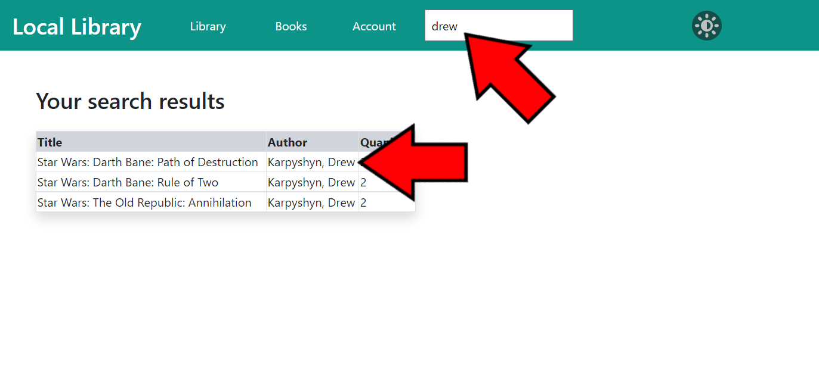On the navigation bar on each page of the library website is a **search bar**. The search bar allows users to search for books using keywords and will display a list of books that match those keywords. (Figure 3-10) The keywords are compared to the books’ titles, authors’ names, and languages.

Figure 3-10   
Search Bar Results Page

#### 3.3 Other Catalog Features

The catalog on the library website hosts various other features, including a book of the day collection and similar book recommendations, detailed in the following sections.

3.3.1 Book of the Day Collection

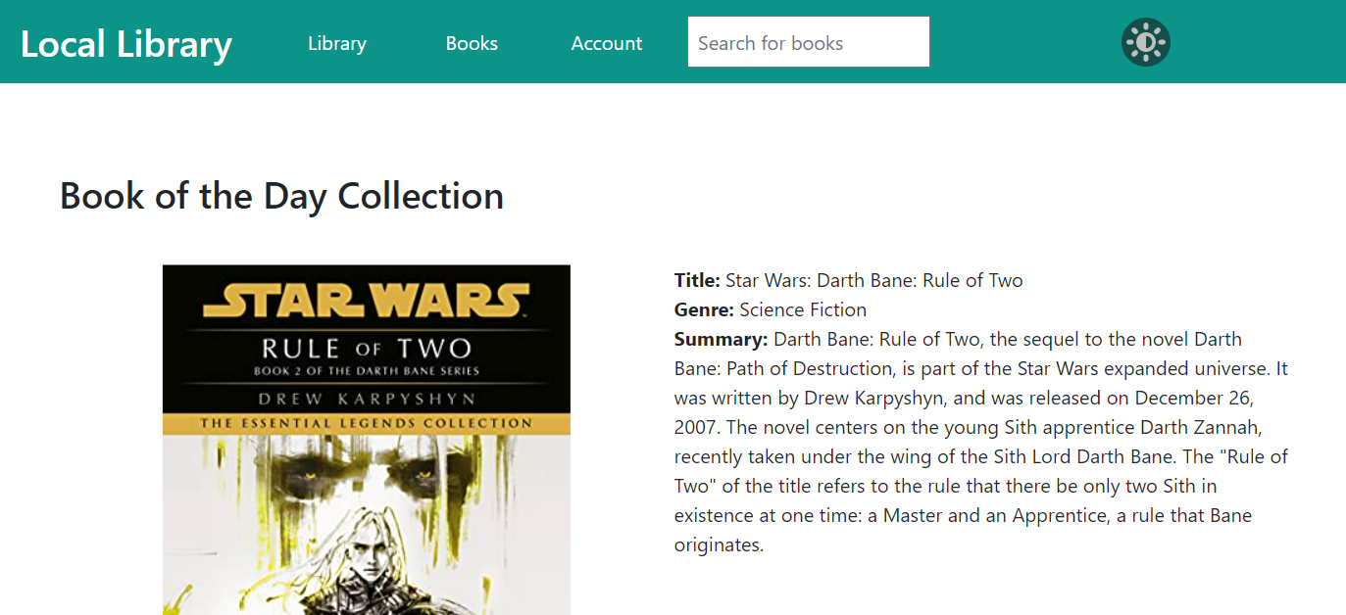On the library website’s home page is a **Book of the Day Collection**. (Figure 3-11) The book in this section changes on each visit and gives users a preview of what kind of books are in the library’s catalog. If you want to view more information about the book of the day, you can click on the title of the book to be brought to the book’s detail page.

Figure 3-11 Library Home Page Showing Book of the Day Collection

3.3.2 Similar Book Recommendations

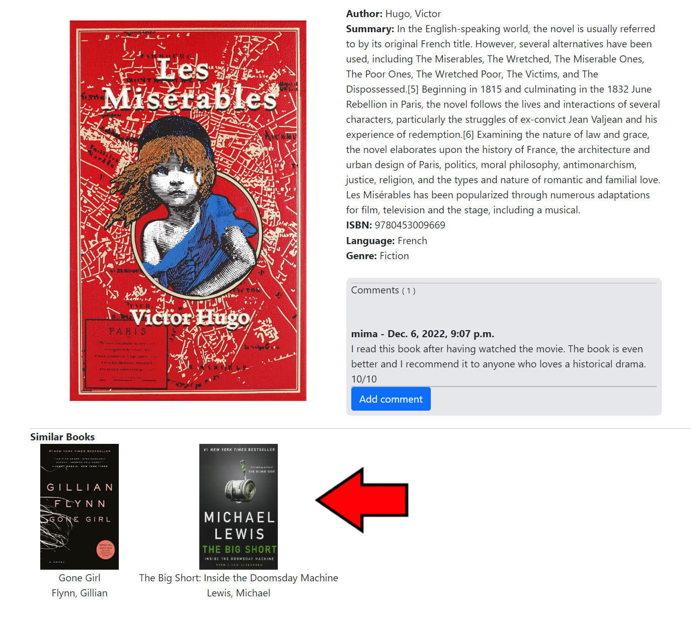On each book detail page in on the library website is a section of **similar book recommendations**. (Figure 3-12) These books share similar characteristics, such as author, genre, or language.

Figure 3-12  
Book Detail Page Showing Similar Book Recommendations

#### 3.4 Editing Catalog Content

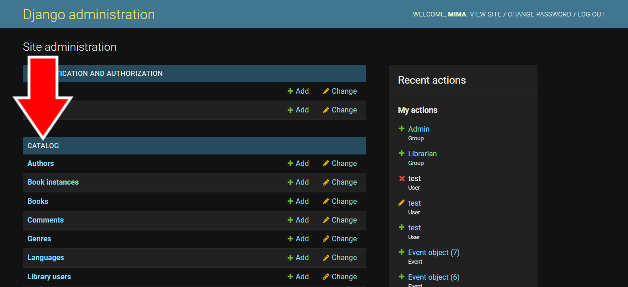Information in the library catalog can be changed from the **Admin Page**. Books, authors, genres, languages, book instances (or copies), and book comments can all be changed from here. Once logged in with an administrative or staff account, select the option you want to edit (for more information on how to log in to the admin page, see section 2.1.1, number 1). Either select the name of the option or press the **Change** button next to it. (Figure 3-13)

Figure 3-13 Site Administration Page Showing Catalog Categories

## 4. Library Information

Important information about the library can be found on the library website, including contact information, hours of operation, location address, and library events.

#### 4.1 About

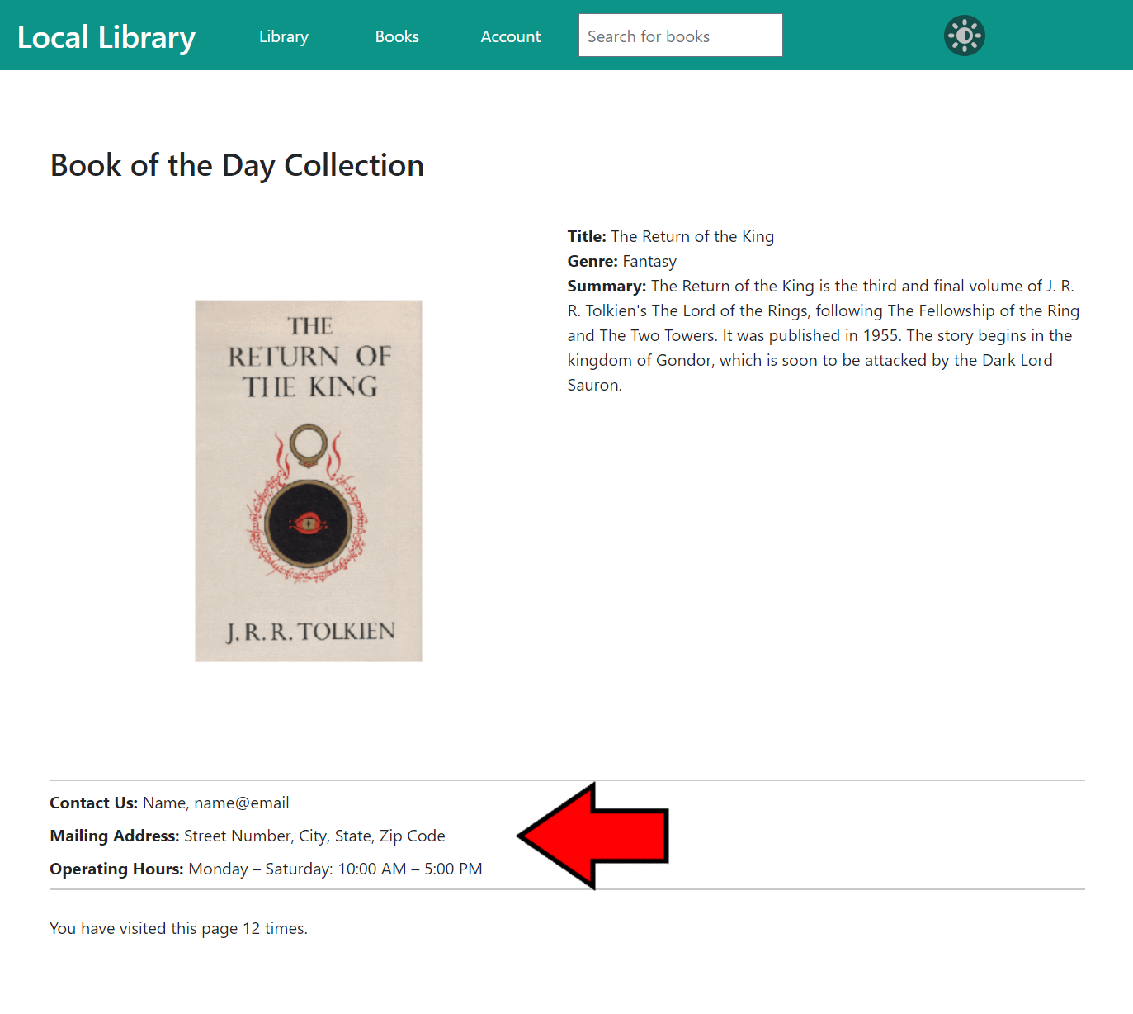Information regarding the physical library can be found on the library website home page, underneath the **Book of the Day Collection**. (Figure 4-1) This section contains the library’s contact information, hours of operation, and physical address.

Figure 4-1   
Library Home Page Showing About Section

#### 4.2 Calendar

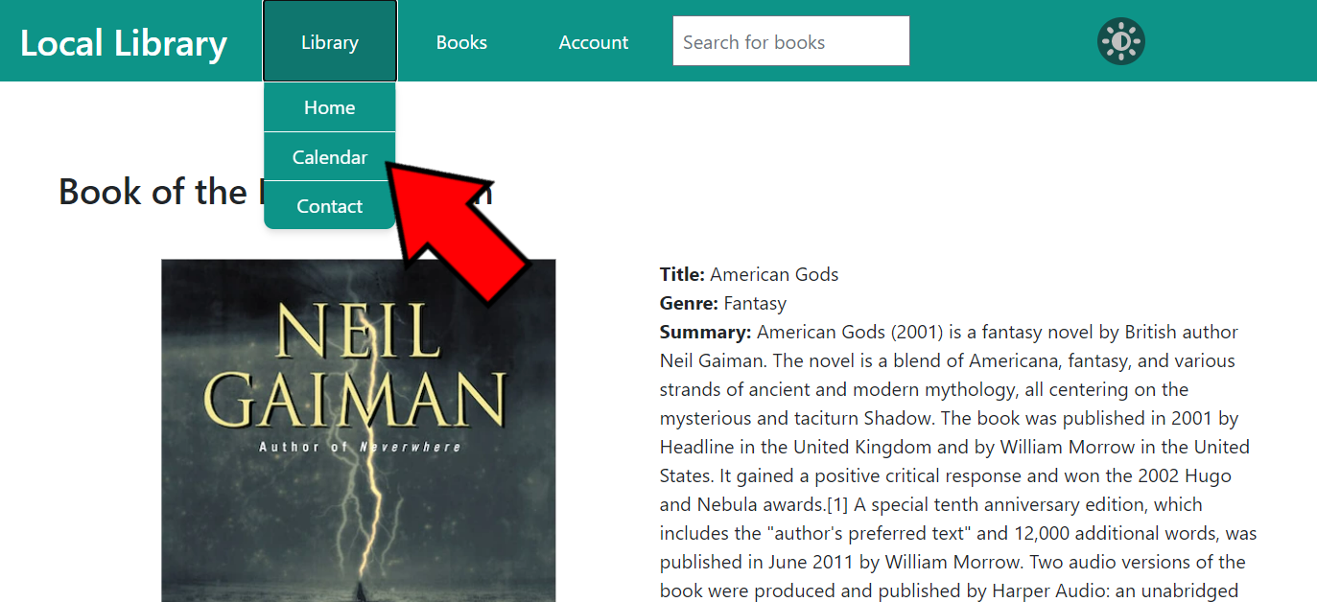The **Calendar** page can be accessed from any page on the library website via the navigation bar at the top. Click on **Library** to open the drop-down menu and click on **Calendar**. (Figure 4-2)

Figure 4-2   
Library Home Page Showing Calendar Button

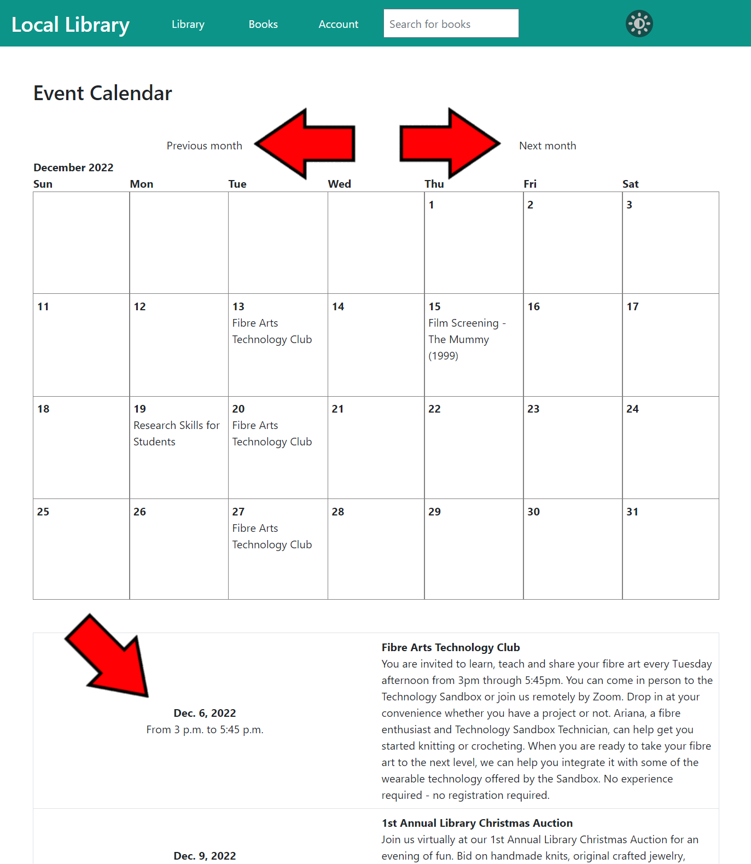On the **Calendar** page is a monthly view of the events the library is hosting. You can change which month you are viewing by clicking the **Previous month** and **Next month** buttons above the calendar. Below the calendar is a list view of the selected month’s events, including information such as event name, day, time, and description. (Figure 4-3)

Figure 4-3  
Calendar Page Showing Month Buttons and Event Details

#### 4.3 Contact

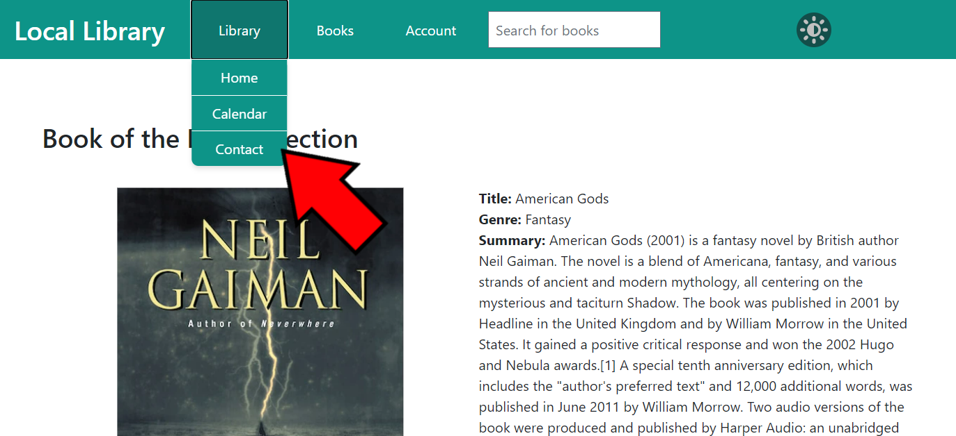The library website has a page where users or visitors can contact the library staff with their questions or concerns. The **Contact** page can be accessed from any page on the library website via the navigation bar at the top. Click on **Library** to open the drop-down menu and click on **Contact**. (Figure 4-4)

Figure 4-4   
Library Home Page Showing Contact Button

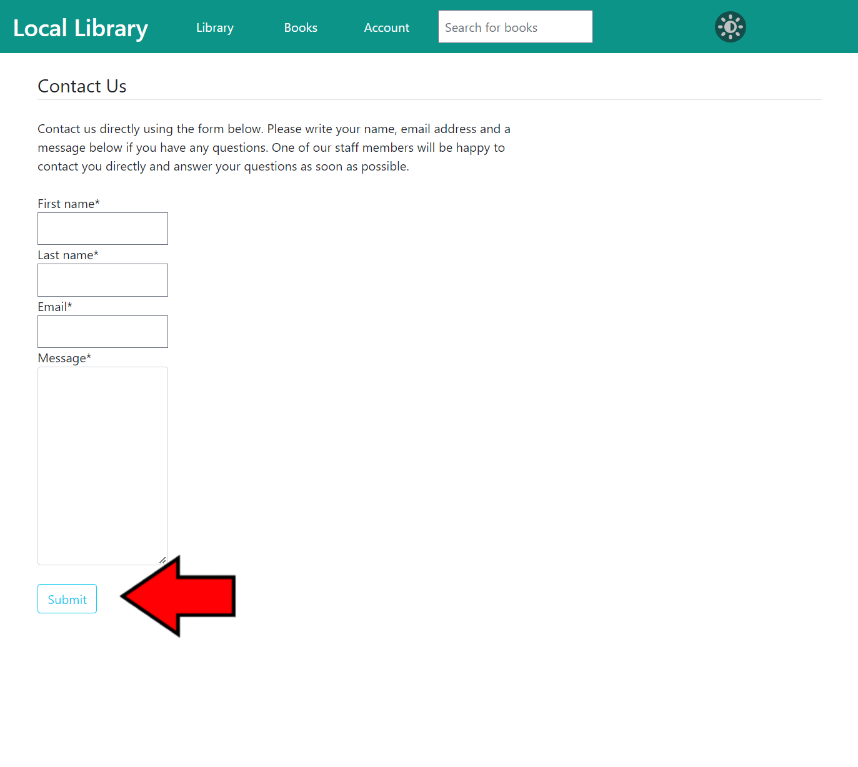To use the **Contact Us** form, fill out each field (**First name, Last name, Email,** and **Message**) then click **Submit** at the bottom of the form. (Figure 4-5)

Figure 4-5   
Contact Us Page Showing Submit Button

4.3.1 Contact Staff View

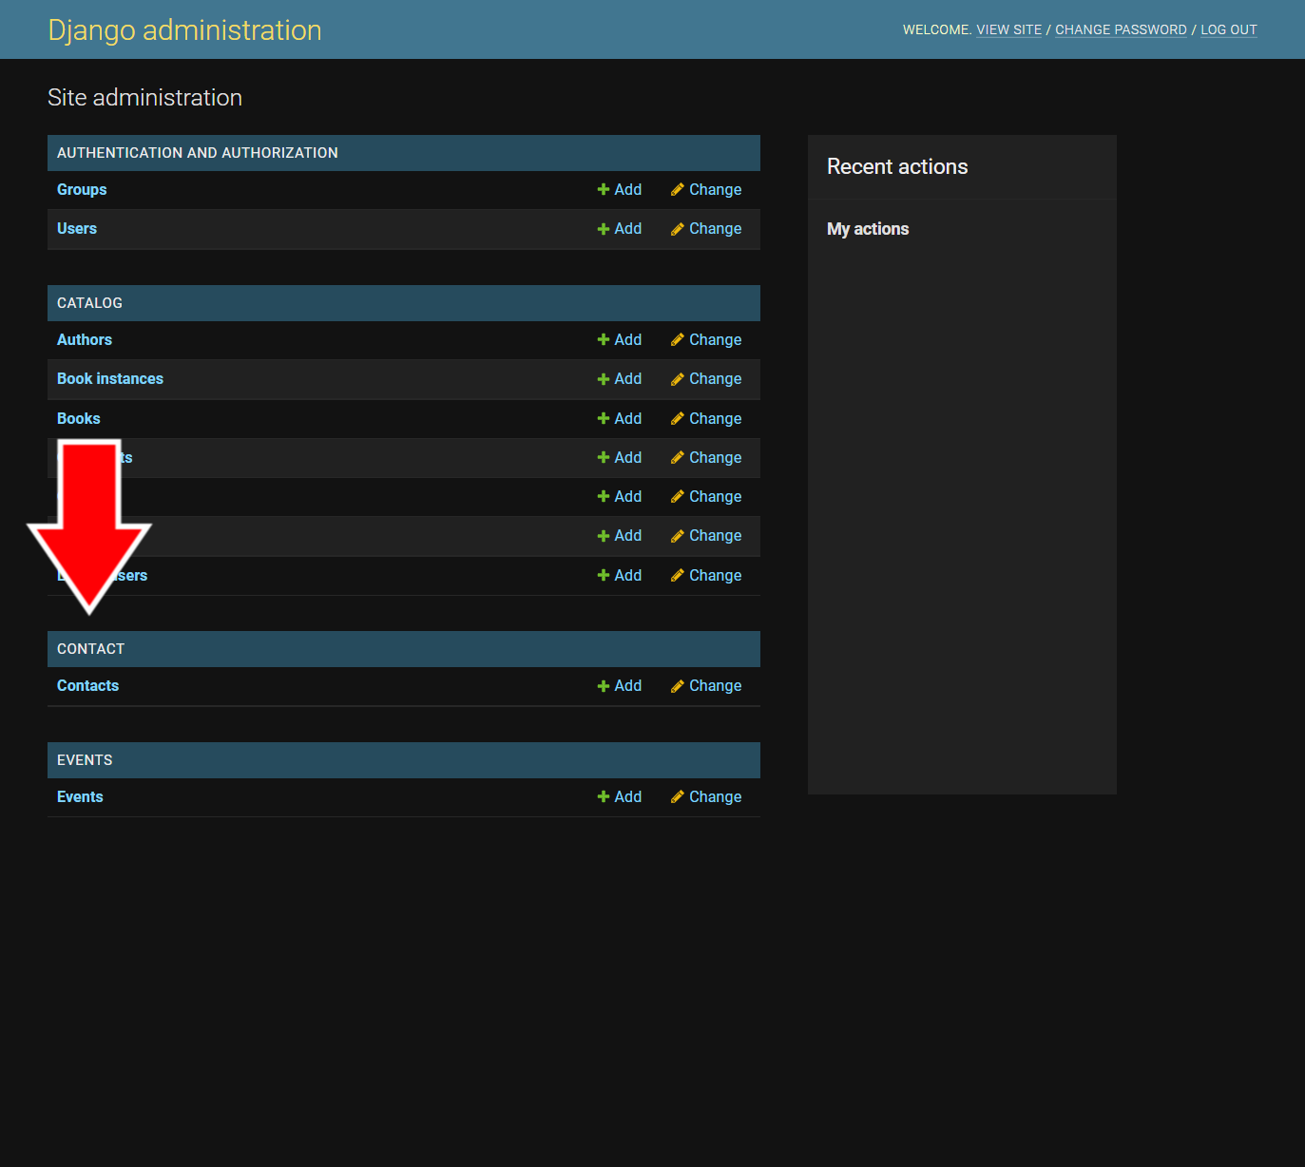Correspondence from the **Contact** page can be viewed on the **Admin Page**. Once logged in with an administrative or staff account, select **Contacts** under the **Contact** category (for more information on how to log in to the admin page, see section 2.1.1, number 1). (Figure 4-6)

Figure 3-13 Site Administration Page Showing Catalog Categories

Figure 4-6   
Site Administration Page Showing Contacts

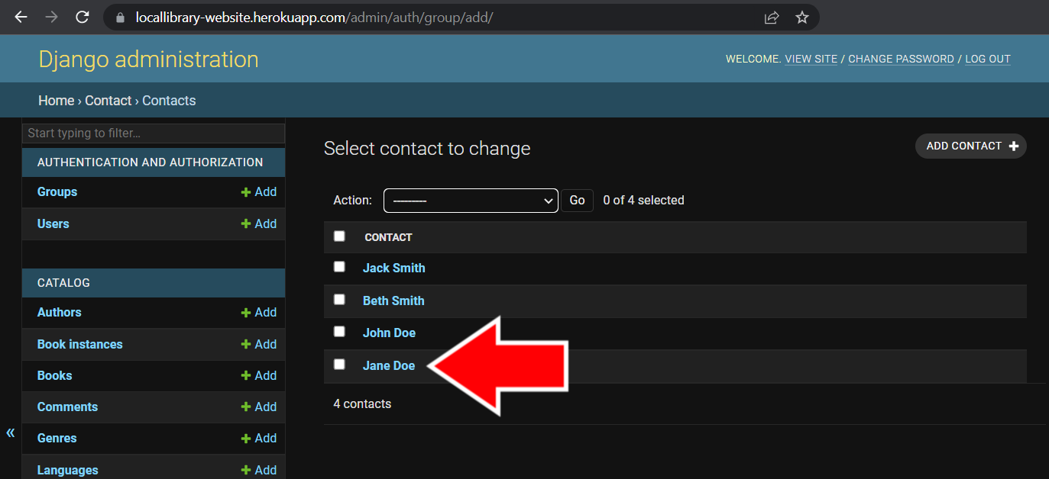To view the details of a correspondence, click on the name of the contact on the **Contacts** page. (Figure 4-7)

Figure 4-7  
Contacts Page

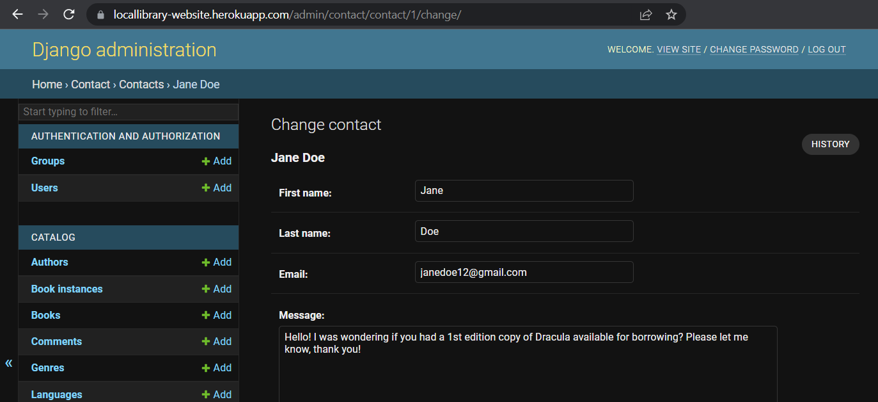On each individual correspondence page is the name of the person who submitted the form, the e-mail address in which to get ahold of them, and a message of their question or concern. (Figure 4-8)

Figure 4-8   
Correspondence Page

## 5. Dark Mode

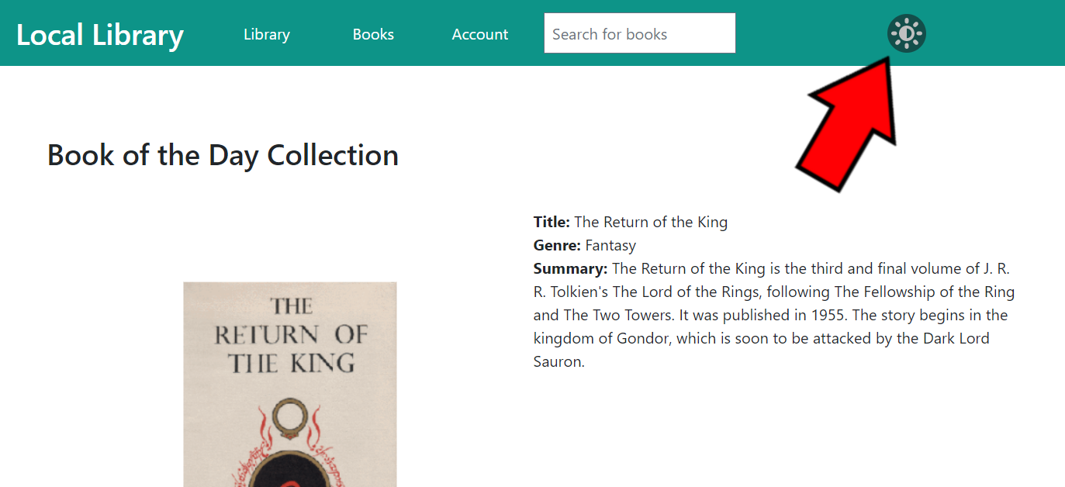The library website has the option to be viewed in **Dark Mode**, which makes the screen less bright to view by changing the colors of the website to dark gray and the text to white. Dark mode can be turned on or off on any page of the website by pressing the **sun button** on the right side of the top navigation bar. (Figure 5-1)

Figure 5-1 Library Home Page Showing Dark Mode Button

Below is a preview of what a page looks like in light mode versus dark mode (Figure 5-2):

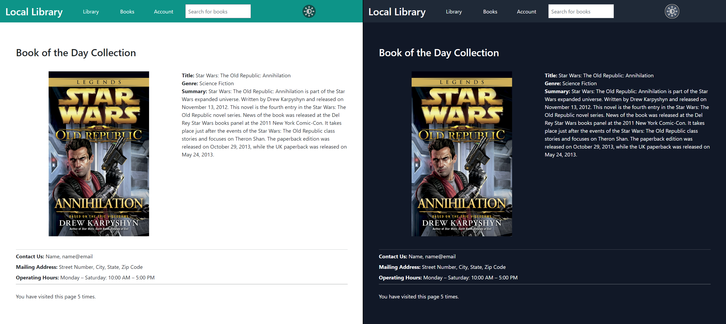

Figure 5-2 Library Home Page Showing Light Mode (left) and Dark Mode (right)

## 6. Glossary

**active** – Refers to the status of a user account. An account that has been designated as “active” can be logged into and used by the user. Any account that is not designated as “active” will not be able to log in to the website and use account features.

**admin page** – The section of the library website used for administration and staff. The website can be viewed by going to [librarywebsite].com/admin and logging in with an administrative or staff account. The admin page gives access to changing all of the information on the library website, including the catalog and user accounts.

**administrative** – Refers to high level users or staff responsible for maintaining the website.

**book instance** – Refers to the individual copies of a book in the library. Each book instance has a unique identification number for differentiation. Also see **copy**.

**catalog** – The collection of books in the library. In reference to the library website, refers to the collection of books that are registered on the website.

**contacts** – The correspondence received from the Contact Us page on the website. Includes the sender’s information such as first name, last name, e-mail, and message.

**copy** - Refers to the individual copies of a book in the library. Each copy has a unique identification number for differentiation. Also see **book instance**.

**detail page / view** – A page that has detailed information. A book detail page has all of the details of that specific book, including title, author, summary, etc. An author detail page has all of the details of that specific author, including name, significant dates, biography, etc.

**events** – Refers to the events being hosted by the library that are displayed on the Calendar.

**groups** – Refers to the collection of permissions given to user accounts. Account permissions can be arranged into groups, making it easier to keep track of which accounts have which permissions. Also see **permissions**.

**library user** – An account on the library website that is specified as a “library user” refers to a user account with access to borrow books, similar to having a library card. An account that is not a “library user” can only view the catalog, not borrow books.

**list page / view** – A page on the website that lists subcategories or books in the selected category. Example: The Genre list page shows a list of all genres on the website.

**permissions** – Refers to the ways a user account can interact with the website. Having more permissions means allowing an account to be more interactive with the website. Some permissions are reserved for administrative or website maintenance staff only. It is important to set up each account with proper permissions. For more information on permissions, see section 2.3.1. Also see **groups**.

**superuser** – User accounts with all permissions. This type of account is reserved for administrative or website maintenance staff only.